2.33: a) The maximum speed will be that after the first 10 min (or 600 s), at which time the speed will be

b) During the first 15 minutes (and also during the last 15 minutes), the ship will travel 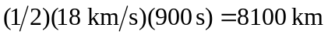, so the distance traveled at non-constant speed is 16,200 km and the fraction of the distance traveled at constant speed is
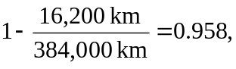
keeping an extra significant figure.
c) The time spent at constant speed is 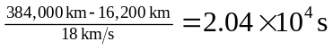 and the time spent during both the period of acceleration and deceleration is 900 s, so the total time required for the trip is 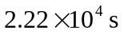, about 6.2 hr.

